Add company’s logo
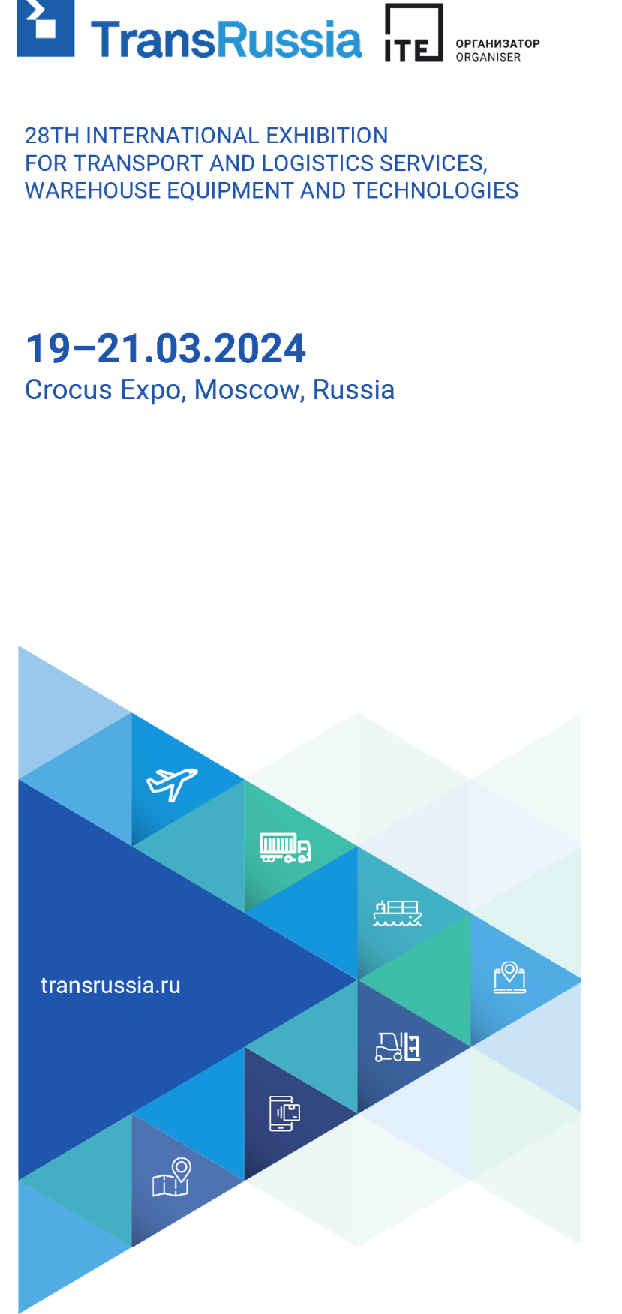

INVITATION TO TRANSRUSSIA 2024

Dear colleagues,
_____________ invites you to visit our stand ________ at 28th International Exhibition for transport and logistic services, warehouse equipment and technologies TransRussia 2024.
The exhibition will be held from March, 19th till March, 21st 2024 in Moscow, Crocus Expo, Pavilion 3 (Myakinino metro station).
PROMOCODE
tr24_____
TransRussia – is the largest logistics exhibition in Russia and CIS. 13 sections of TransRussia, together with a special SkladTech exposition, cover the entire supply chain.

_________ is a long-term exhibitor and this year is the ____ time we participate in TransRussia.

Get your free e-ticket>> using our promocode tr24_____________.
The number of promocode usage is unlimited.

At our stand you will find:

SEE YOU AT TRANSRUSSIA 2024!

Opening hours and venue’s address are on the website.
Contact person:_______________________________________________

